Custom Bank Integrations vs Third-Party Payment Platforms
# Source: Chatgpt (GPT-5-Mini) at [1/21/2026]
Excellent question! Here's a clear breakdown of custom bank integrations vs third-party payment platforms, so you understand the differences, pros, and cons, and when to choose which for your website or app.

🏦 1. Custom Bank Integrations
# Source: Chatgpt (GPT-5-Mini) at [1/21/2026]
Custom bank integration means you connect directly to a bank’s API or system to accept payments (e.g., card payments, direct bank transfers, wallets).

🔧 How it works:
# Source: Chatgpt (GPT-5-Mini) at [1/21/2026]
You (the developer or business) build your own:
- Checkout flow
- Security measures (PCI compliance)
- Transaction logic
- Bank API calls
The bank provides:
- API documentation
- Access to test/sandbox and live environments

✅ Advantages:
# Source: Chatgpt (GPT-5-Mini) at [1/21/2026]
- Lower transaction fees (no third-party markup)
- More control over the payment process
- Possibly better local banking support (especially for Egypt or MENA)
- Easier to settle directly to your business account

🔴 Disadvantages:
# Source: Chatgpt (GPT-5-Mini) at [1/21/2026]
- Requires development effort
- You must handle compliance, security (PCI DSS), and fraud protection
- Can be time-consuming to implement
- Limited payment methods (mostly just cards or bank transfers)

💡 Use when:
# Source: Chatgpt (GPT-5-Mini) at [1/21/2026]
- You have a tech team and want full control
- You're working with a large local bank in your country
- You want direct local settlement (e.g., receiving money directly in an Egyptian bank account)

🌐 2. Third-Party Payment Platforms
# Source: Chatgpt (GPT-5-Mini) at [1/21/2026]
Third-party payment platforms (also called payment service providers) handle everything for you: gateway, processor, security, and sometimes even merchant onboarding.

🔧 How it works:
# Source: Chatgpt (GPT-5-Mini) at [1/21/2026]
You integrate with one platform like:
- Stripe, Paymob, PayPal, Fawry, Razorpay, Flutterwave, etc.
They:
- Provide ready-made checkout or APIs
- Handle fraud checks and PCI compliance
- Process and settle payments to your bank account

✅ Advantages:
# Source: Chatgpt (GPT-5-Mini) at [1/21/2026]
- Fast and easy integration (often done in 1–2 days)
- Built-in security & compliance
- Accept multiple payment methods (cards, wallets, BNPL, installments)
- Dashboards for tracking transactions and payouts

🔴 Disadvantages:
# Source: Chatgpt (GPT-5-Mini) at [1/21/2026]
- Higher fees per transaction (3–4% typical)
- Funds may take 1–3 days to settle
- Less flexibility or customization at a low level
- Some providers don’t fully support all countries or currencies

💡 Use when:
# Source: Chatgpt (GPT-5-Mini) at [1/21/2026]
- You want to launch fast
- You’re a startup, SaaS, or e-commerce site
- You want to accept multiple payment methods
- You don’t want to worry about security, fraud, or compliance

🔍 Comparison Table
# Source: Chatgpt (GPT-5-Mini) at [1/21/2026]

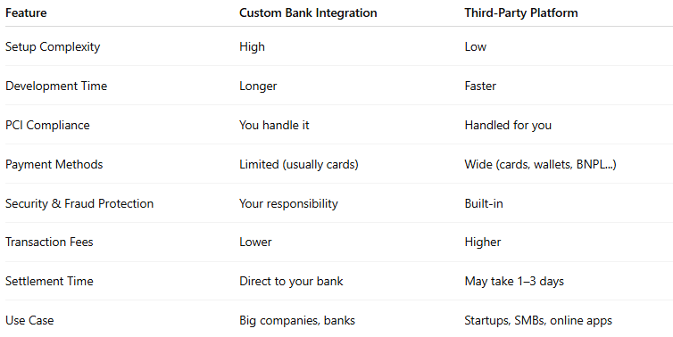

Feature | Custom Bank Integration | Third-Party Platform
Setup Complexity | High | Low
Development Time | Longer | Faster
PCI Compliance | You handle it | Handled for you
Payment Methods | Limited (usually cards) | Wide (cards, wallets, BNPL...)
Security & Fraud Protection | Your responsibility | Built-in
Transaction Fees | Lower | Higher
Settlement Time | Direct to your bank | May take 1–3 days
Use Case | Big companies, banks | Startups, SMBs, online apps

✅ Which Should You Use?
# Source: Chatgpt (GPT-5-Mini) at [1/21/2026]
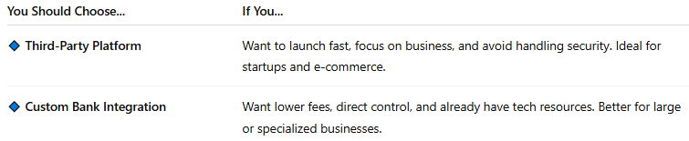
You Should Choose... | If You...
🔹 Third-Party Platform | Want to launch fast, focus on business, and avoid handling security. Ideal for startups and e-commerce.
🔹 Custom Bank Integration | Want lower fees, direct control, and already have tech resources. Better for large or specialized businesses.

